**What is Azure Storage Explorer?**

**Azure Storage Explorer** is a free, standalone tool that allows you to manage and access your Azure storage resources, such as **Azure Blob Storage, File Shares, Queues,** and **Tables,** in a graphical user interface (GUI). It is designed to simplify data management and make it easier to work with Azure Storage, whether you are on-premises or using cloud services.

**Key Features:**

**Manage Blobs:** Upload, download, and organize your blob containers and blobs, including page and block blobs.

**File Shares:** Work with Azure file shares, uploading and downloading files like you would with a traditional file system.

**Table Storage:** Query and edit data in your Azure Table Storage without writing code.

**Queue Storage:** Inspect and manage the contents of your Azure Queues.

**SAS Tokens & Access Control:** Manage Shared Access Signatures (SAS) to control access to resources securely.

**Cross-Platform Support:** Available for Windows, macOS, and Linux.

**Local Emulator:** Integrate with local Azure storage emulators to test and manage storage locally.

It is widely used by developers and IT professionals to easily interact with their Azure storage services without needing to use the Azure portal or write complex code.

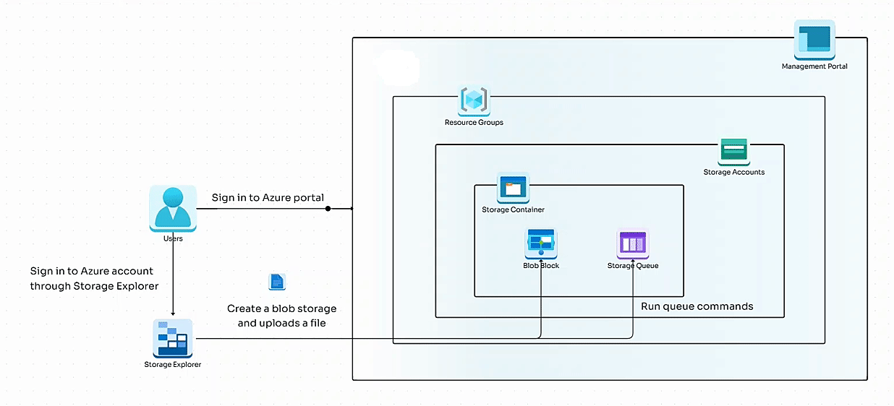

**Lab Details**

In this lab, you'll try Storage Explorer by downloading, installing, and connecting to an Azure Storage account. You'll create a blob and a queue in your storage account.

**Pre-requisites**

In order to continue with this lab, you need to have Azure Storage explorer installed on your system. If it is not already present, you can install it using the following link: [Click here](https://azure.microsoft.com/en-us/products/storage/storage-explorer/?azure-sandbox=true#Download-4)

<https://azure.microsoft.com/en-us/products/storage/storage-explorer/?azure-sandbox=true#Download-4>

# ****Lab Steps****

## ****Task 1: Sign in to Azure portal****

## ****Task 2: Connect to an Azure account on Azure storage explorer****

1. First let's start by logging in to your Azure account through Azure Storage Explorer. Open Storage explorer on your system and then either select **Sign in to Azure** from the home page or click on the profile icon on the left pane and then select **sign in with Azure.**

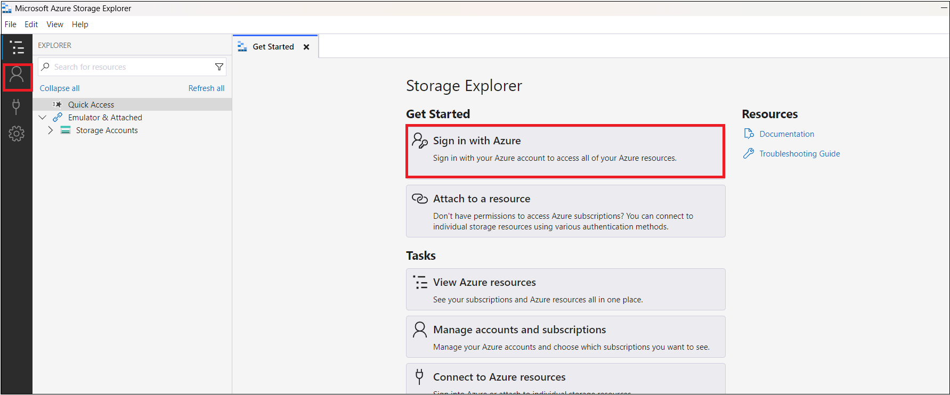

1. There are several Azure environment options to select from. Select **Azure**, then select Next.

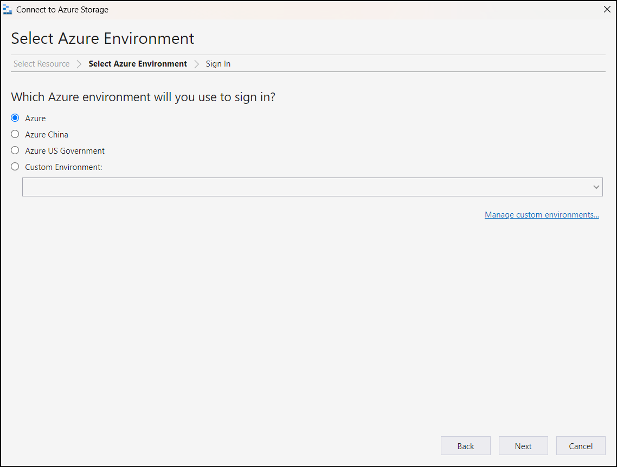

3. Your browser opens and an Azure sign-in page appears. Use your Azure credentials to sign in.

4. When you've signed in to your Azure instance, the associated Azure account and Azure subscription appear in the Account Management section.

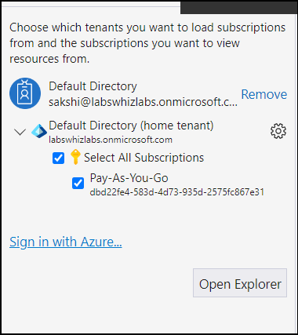

5. Confirm that the **Payg-Lab2** subscription is selected and account details are correct, and then select **Open Explorer**.

* You've now connected Storage Explorer to your Azure subscription. Leave Storage Explorer open while you work through the next steps

## ****Task 3: Create a storage account and add a blob****

1. In the Azure Portal, open the **Bash** session within the **Cloud Shell** pane by clicking on the **Cloud Shell** icon.

https://labresources.whizlabs.com/0440ecdcb85e3370fe50404384781cc9/3_19_17.png

2. Click on **Bash**

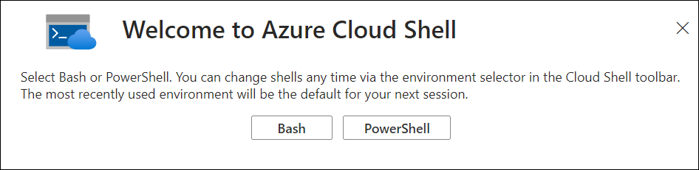

3. In the new box that opens up, select the following:

* Select **No storage account required**
* Subscription: Select **Payg-Lab2**

4. Click on **Create**.

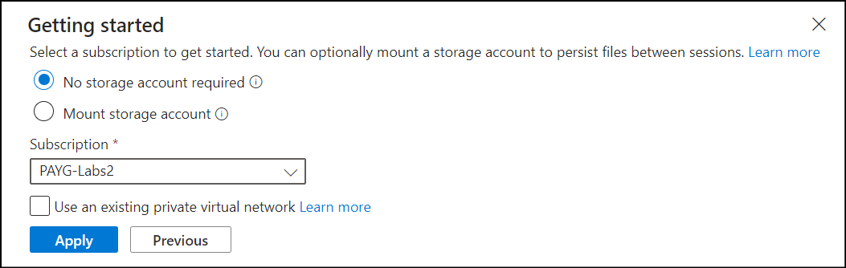

5. In Azure Cloud Shell, run the following command to create a storage account. Replace **<resource-group-name>** with the name of the resource group provided for this lab.

az storage account create --name mslearn$RANDOM --resource-group <resource-group-name> --sku Standard_LRS --kind StorageV2

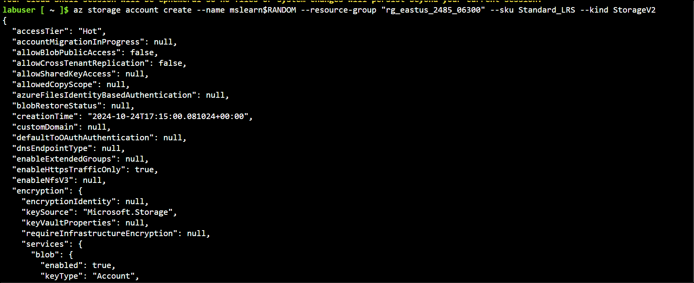

In the output, note the name of the storage account. After the storage account is created, switch back to Storage Explorer.

6. If it isn't currently visible, toggle the **EXPLORER** view so that the pane is shown.

7. In the **EXPLORER** pane, select **Refresh All**, then locate and expand **Payg-Lab2 Subscription**.

8. Locate and expand the storage account that you created earlier. It should be named something similar to **mslearn12345**, ending with a different set of numbers. It has four virtual folders: **Blob Containers, File Shares, Queues,** and **Tables**.

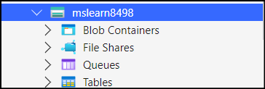

9. Right-click the **Blob Containers** virtual folder to access the shortcut menu, then select **Create Blob Container**.

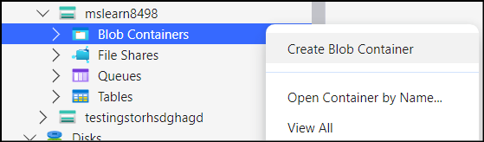

10. Name the container **myblobcontainer** and press Enter.

11. Each created container appears in a tab to the right of the resource tree.

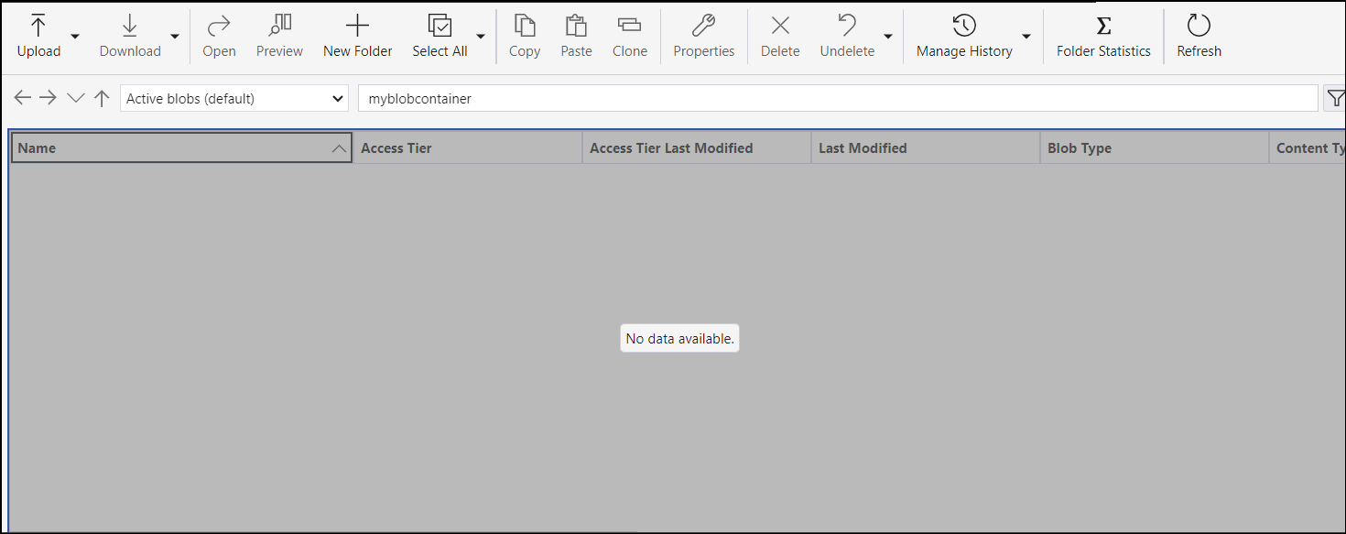

12. Upload a blob to the container. In the **myblobcontainer** pane, select **Upload**, then select **Upload Files**. The **Upload Files** dialog box appears.

13. For **Selected files**, select the ellipsis (**...**). Browse to a small file on your device and select **Open**. Select **Upload** to upload the file.

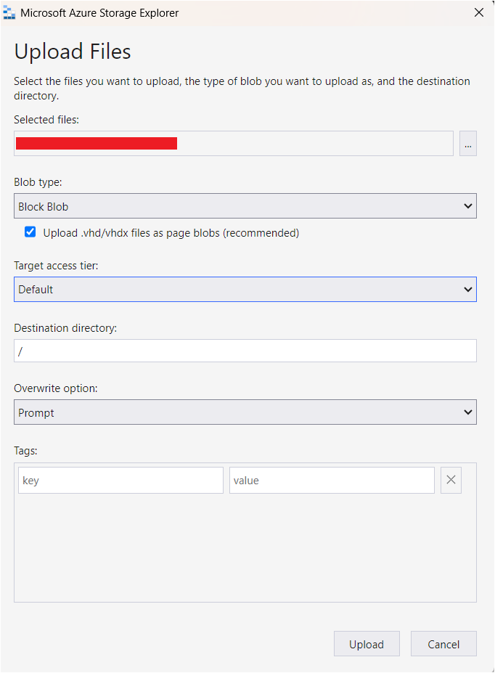

14. You should now see your file stored in your storage account.

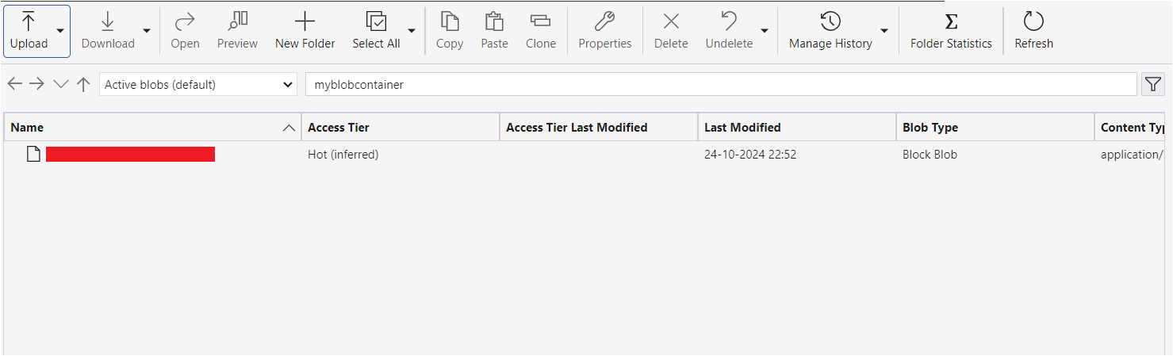

## ****Task 4: Create a queue in your Azure Storage account****

To create a queue in your storage account:

1. In the resource tree, find **Payg-lab2 Subscription** and expand the options.

2. Expand the storage account you created earlier.

3. Right-click the **Queues** virtual folder to access the shortcut menu, then select **Create Queue**.

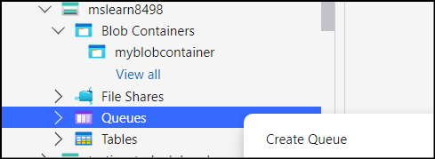

4. An empty and unnamed queue is created inside the **Queues** folder. The queue won't be created until you give it a name.

5. Name this new queue **myqueue** and press Enter to create the queue. Each created queue appears on a tab to the right of the resource tree.

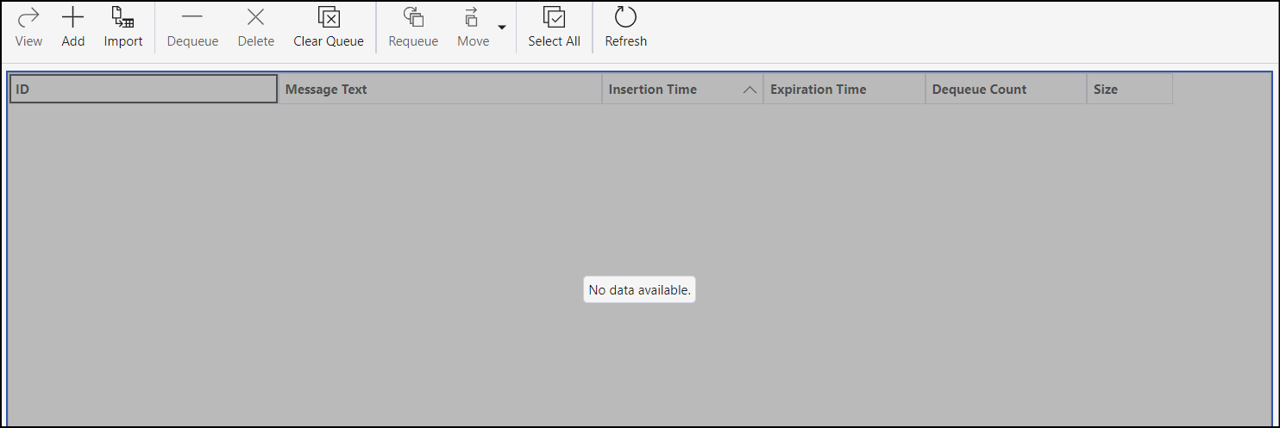

* From this view, you can manage the queue's content. If our application used this queue and experienced an issue with processing a message, you could connect to the queue and view the message contents to determine the issue.

## ****Task 5: Verify the deployments****

Now, lets verify our deployments through the Azure Portal. Go to your storage account and then from the left panel under **storage**, select **containers**. You will see that a container has been deployed successfully. Now enter the container and you will notice that your uploaded file will be visible inside the blob that you had created.

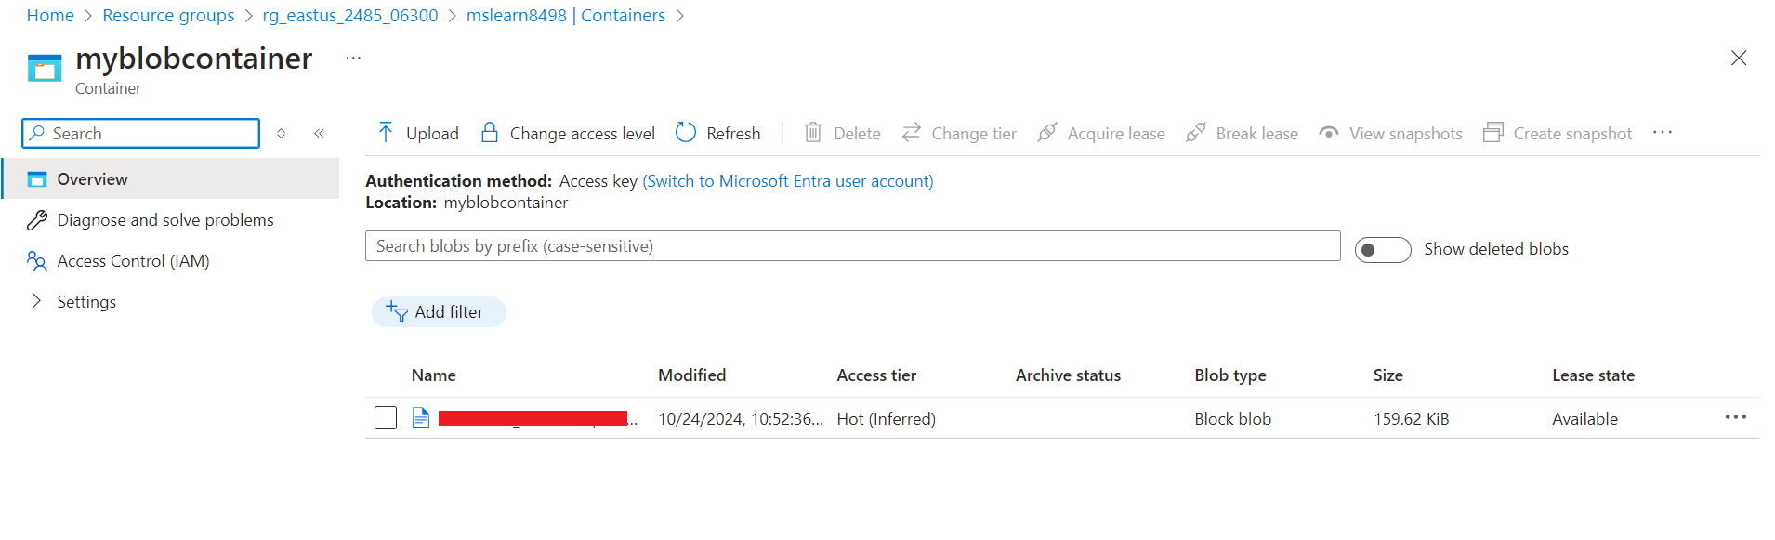

2. In the same way, under **storage**, look for queue and you will see that your created **queue** will be present there.

